COMP1844 Information Analysis and Visualisation
Coursework Report
Module: COMP1844 Information Analysis and Visualisation
Student: Trịnh Tuấn Phong
Student ID: GCS220282
Lecturer: Le Tran Ngoc Tran
Submission Date: 25/04/2004

Table of Contents

I. Introduction

II. Single-Line Transport Graph
2.1 Objective
2.2 Methodology
2.3 Python Code
2.4 Generated Visualization

III. Multi-Line Connected Transport Graph
3.1 Objective
3.2 Methodology
3.3 Design Strategy
3.4 Python Code
3.5 Generated Visualization
3.6 Color Scheme and Key

IV. Network Analysis
4.1 Objective
4.2 Methodology
4.3 Python Code
4.4 Results and Interpretation

V. Discussion and Evaluation
5.1 Challenges Encountered
5.2 Accuracy of Representation
5.3 Use of Visualization Tools
5.4 Improvements and Future Work

VI. Conclusion

VII. References

VIII. Appendix

I. Introduction
This coursework uses graph data structures to represent part of the London public transport network. The project consists of three tasks. Task 1 creates a transport graph with three lines and replaces the edge labels with real distances between stations. Task 2 expands the graph to include at least five connected lines with a consistent colour scheme and interchange stations. Task 3 analyses the completed network by calculating the total length, average distance, and standard deviation of all connections. The program is developed using only NumPy, pandas, NetworkX, and Matplotlib. The final result demonstrates how graph visualisation can be used to represent and analyse a transport network in a simple and clear way.

II. Single-Line Transport Graph

2.1 Objective
The objective of this task is to create a graph that represents three London Underground lines using NetworkX. Each station is shown as a node, while each connection between stations is shown as an edge. The original edge labels are replaced with approximate distances collected from online map services. The graph should clearly display the transport lines using different colours and provide an accurate and readable visualisation.

2.2 Methodology
The graph was created by defining stations as nodes and connecting them with edges that store distance information. Different colours were assigned to each transport line to improve readability. The positions of the stations were adjusted manually so the graph follows the style of a transport map rather than the real geographic layout. Finally, edge labels were added to display the distances between connected stations.

2.3 Python Code
The program starts by importing NumPy, pandas, NetworkX, and Matplotlib. A graph object is created, followed by adding station nodes and edges with distance values. Each edge is assigned to a transport line and displayed using a specific colour. NetworkX is used to build the graph structure, while Matplotlib draws the final transport map with station names and distance labels.
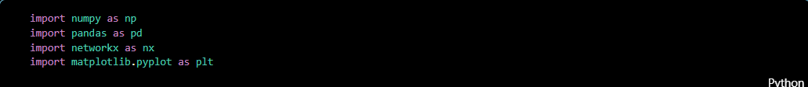
Figure 1. The Python program begins by importing the required libraries.
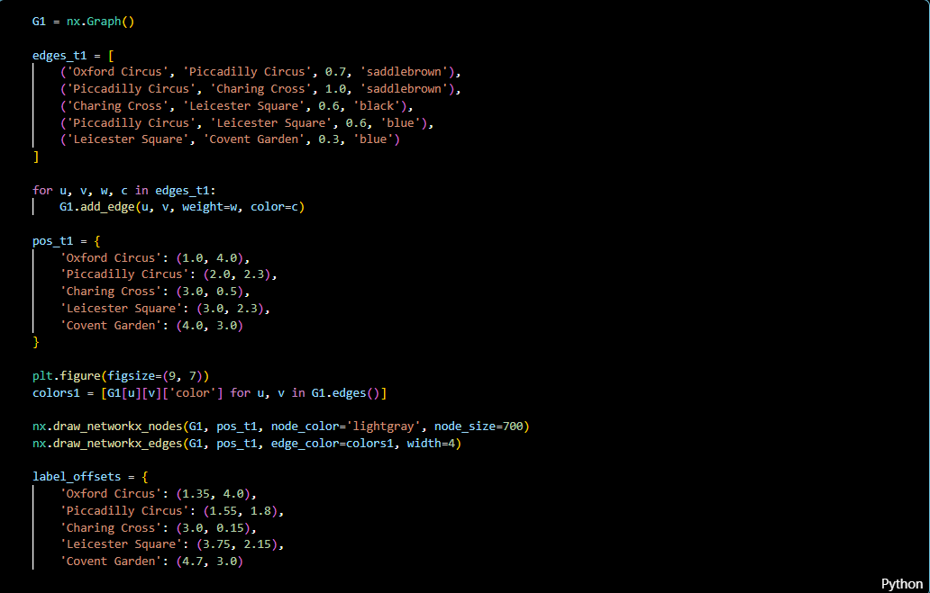
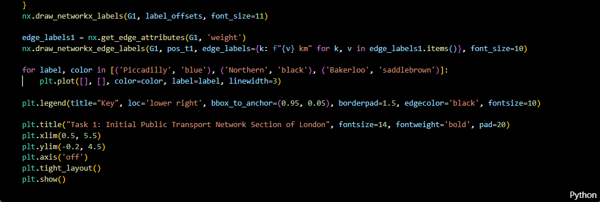
Figure 2. Python code for intial public graph

2.4 Generated Visualization
The generated graph successfully shows three transport lines with coloured edges and labelled stations. Distance values are displayed on every connection, making the network easier to understand than the original example. The visualisation is clear, organised, and matches the coursework requirements.
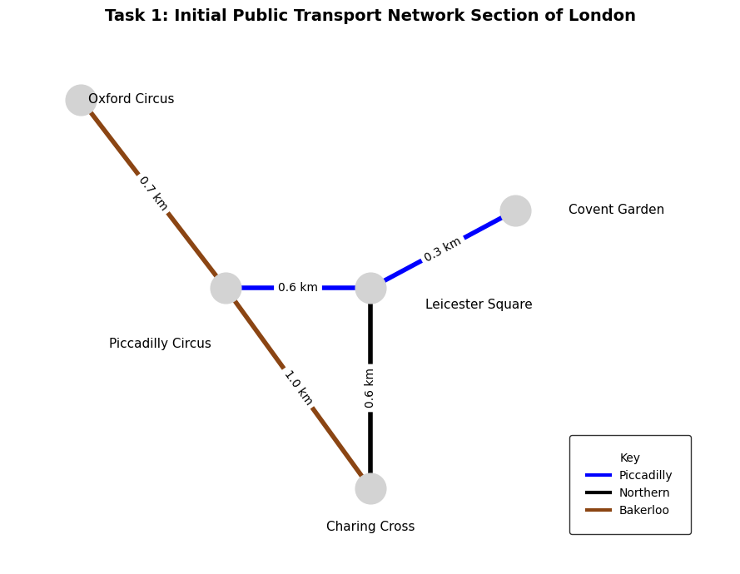
Figure 3. Output of task 1 code

III. Multi-Line Connected Transport Graph

3.1 Objective
The objective of Task 2 is to expand the transport network created in Task 1. The graph is extended to include at least five transport lines, with a minimum of six stations on each line. The network must remain connected so that passengers can travel between any two stations. The graph should also use a consistent colour scheme and include a key to identify each transport line.

3.2 Methodology
The existing graph was expanded by adding new stations and connections based on a section of the London Underground network. Interchange stations were used to connect different lines and ensure that every station can be reached from any other station. Each line was assigned a unique colour, and approximate distances between neighbouring stations were added as edge labels. The layout was adjusted manually to improve readability while keeping the appearance similar to a real transport map.

3.3 Design Strategy
The transport network was designed to represent a realistic part of the London Underground rather than the complete system. Only selected stations were included to keep the graph clear and easy to understand. Interchange stations play an important role because they connect different lines and allow passengers to change routes. A simple colour scheme was used throughout the graph so that each line can be recognised easily.

3.4 Python Code
The program extends the graph by adding additional nodes and edges for the new transport lines. Each edge contains the transport line name and the distance between two stations. Colours are stored for each line and used when drawing the graph. The completed graph is then displayed with labelled stations, coloured lines, distance labels, and a key showing the name of each transport line.
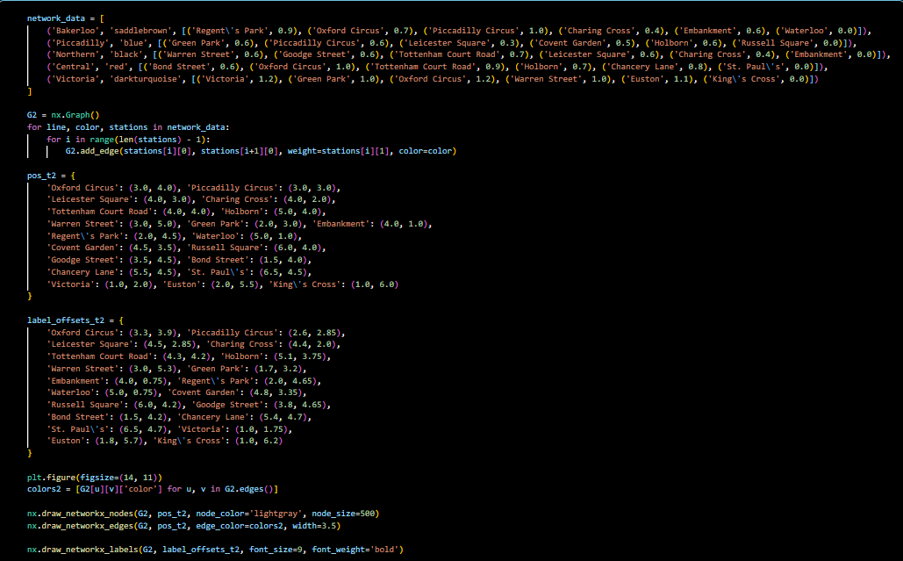
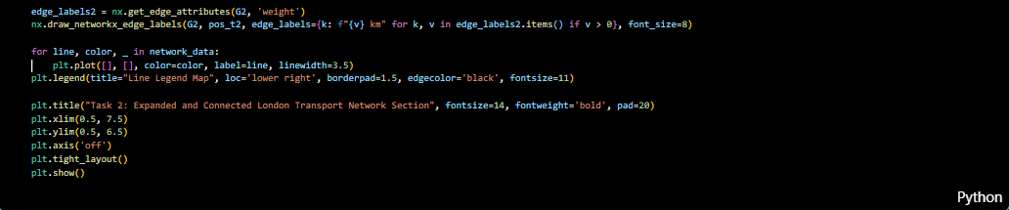
Figure 4. Python code for multi line transport graph

3.5 Generated Visualization
The completed graph contains five transport lines with more than six stations on each line. All stations are connected through one or more interchange stations, allowing travel between any two locations. Distance labels are shown for every connection, and different colours clearly distinguish the transport lines. The final visualisation is organised, easy to read, and satisfies the coursework requirements.
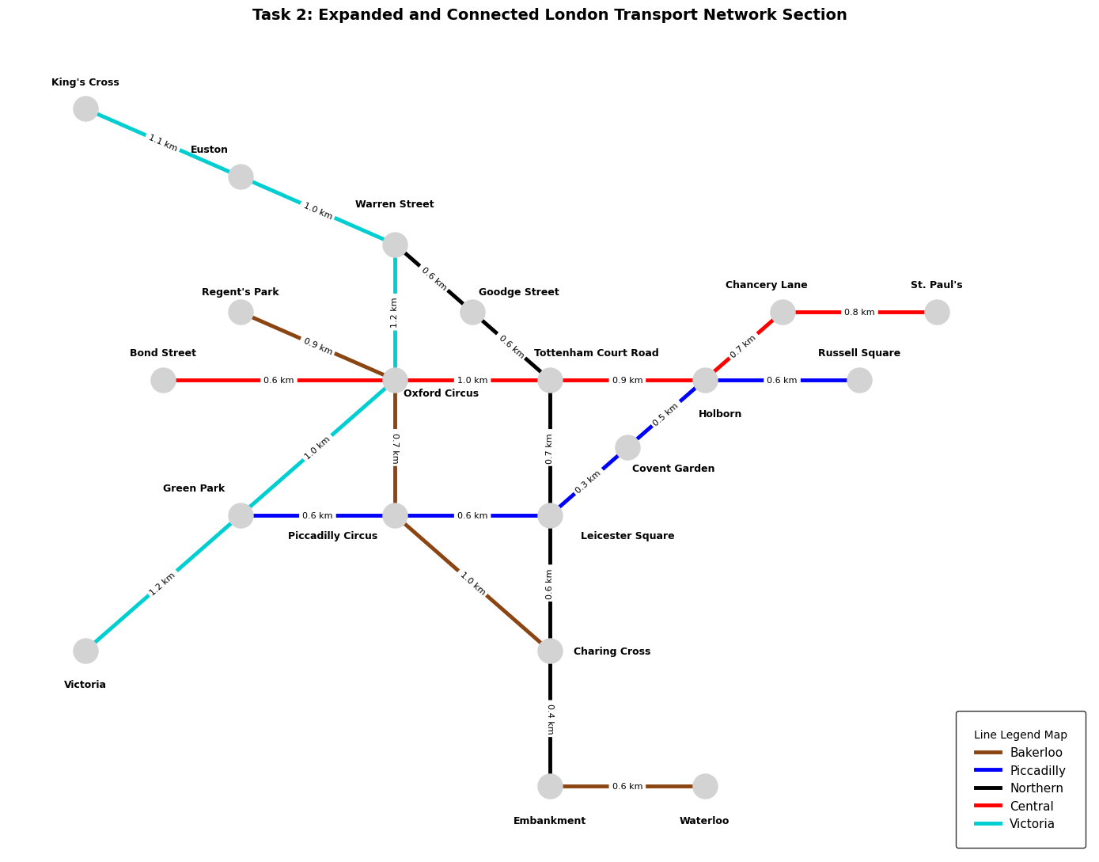
Figure 5. Output of task 2 code

3.6 Colour Scheme and Key
Each transport line is represented by a different colour to improve readability and make the map easier to understand. A key is included beside the graph to identify the corresponding line for each colour. This consistent colour scheme helps users quickly follow routes and recognise interchange stations when moving between different transport lines.

IV. Network Analysis

4.1 Objective
The objective of Task 3 is to analyse the completed transport network using the graph created in Task 2. The program calculates the total length of the network, the average distance between stations, and the standard deviation of all edge distances. These values provide a simple overview of the transport network.

4.2 Methodology
The distance values stored on each edge were extracted from the graph and converted into a numerical dataset. NumPy was used to calculate the total length, average distance, and standard deviation. The results were then displayed in a clear format so that the network could be evaluated easily.

4.3 Python Code
The program reads all edge distances from the graph and stores them in a list. NumPy functions are then used to calculate the required statistics. Finally, the results are printed to the console.
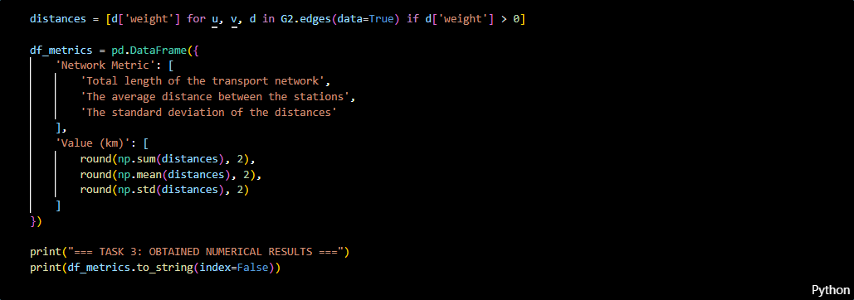
Figure 6. Python code program for calculating and computing

4.4 Results and Interpretation
The calculated results show the overall characteristics of the transport network. The total length represents the sum of all connections, while the average distance shows the typical distance between two neighbouring stations. The standard deviation indicates how much the distances vary across the network. These values help evaluate whether the transport network is balanced and realistic.
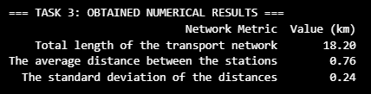
Figure 7. The computing’s result

V. Discussion and Evaluation

5.1 Challenges Encountered
One of the main challenges was selecting a suitable section of the London Underground while keeping the graph connected. Another challenge was arranging the stations so that the graph remained clear and easy to read without overlapping nodes or labels.

5.2 Accuracy of Representation
The transport network is based on a real section of the London Underground, although it is not geographically exact. The station connections and approximate distances are realistic enough to satisfy the coursework requirements while keeping the graph simple and readable.

5.3 Use of Visualization Tools
NetworkX provided an efficient way to build the graph and manage nodes and edges. Matplotlib was used to display the network with coloured transport lines, labelled stations, and distance values. NumPy and pandas supported the numerical analysis and data organisation.

5.4 Improvements and Future Work
The project could be improved by adding more transport lines and stations to represent a larger part of the London Underground. Additional features, such as shortest path calculation or route planning, could also be included. A more accurate geographical layout would make the map closer to the real transport network.

VI. Conclusion
This coursework successfully developed a transport network using graph data structures in Python. The first task created a simple graph with three transport lines and distance labels. The second task expanded the network to include five connected lines with a consistent colour scheme and interchange stations. Finally, the third task analysed the network by calculating its total length, average distance, and standard deviation. Overall, the project demonstrates how graph visualisation can be used to represent and analyse a transport network in a clear and effective way.

VII. References
NetworkX Developers. (2025). NetworkX Documentation. https://networkx.org
Matplotlib Development Team. (2025). Matplotlib Documentation. https://matplotlib.org
NumPy Developers. (2025). NumPy Documentation. https://numpy.org
pandas Development Team. (2025). pandas Documentation. https://pandas.pydata.org

VIII. Appendix
Appendix A. Task 1 Source Code
(Insert the complete Task 1 Python code from main.ipynb.)
Appendix B. Task 2 Source Code
(Insert the complete Task 2 Python code from main.ipynb.)
Appendix C. Task 3 Source Code
(Insert the complete Task 3 Python code from main.ipynb.)
Appendix D. Generated Images and Results
- Task 1 generated transport graph.
- Task 2 generated transport graph.
- Task 3 numerical results (total length, average distance, and standard deviation).

